Pirate Ship --- Step-by-Step Robot Tutorial

在基础功能这个板块，可以让你的机器人实现最最简单的移动，比如前进，后退，左转，右转等等。有让你的机器人很快就活起来的简单代码，轻松上手。还等什么，那就开始吧！按照我们的步骤，一步一步来制作你的机器人。对了，做机器人工具可不能少。在做机器人之前，你还需要准备以下这些工具。

Are you excited about building your first robot? Isn’t it cool to make your own robot, which can move forward, move back, turn left and turn right? In this tutorial, you can learn all the basics: how to use the tools, how to assemble your own robot, how to program and how to make your robot move. Before we start building, let’s prepare the following tools.

必备工具

**Essential Tools**

* [螺丝刀](http://www.dfrobot.com.cn/goods-797.html)
* **Screwdriver**

螺丝刀，是机器人制作非常必要的工具。不用多说，用来拧螺丝的。建议你可以买一套完整的螺丝刀套件。面对不同型号的螺丝，使用起来就得心应手了。

Screwdriver, a tool for turning screws (driving or removing) is indispensable for building a robot. We suggest that you get yourself a screwdriver set, which is extremely convenient in dealing with screws of different types and sizes.

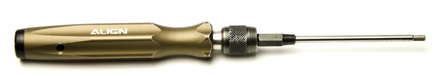

* [电烙铁](http://www.dfrobot.com.cn/goods-977.html)
* **Soldering Pencil**

电烙铁是常用来焊接电子元器件的工具，也是我们做一些电子制作的必备工具。我们这里需要用来焊接电机线的。

A soldering pencil is a tool frequently used in electronics projects for soldering and de-soldering work on circuit boards. We’ll need it in this project to solder the motors’ cables.

注意：因为电烙铁加热后，烙铁头温度相当高！如果你从未使用烙铁，建议先对烙铁使用有个简单认识之后再使用。使用时，请注意安全！

NOTE: Once heated, the tip of the soldering pencil will become extremely hot. If you have never used a soldering pencil before, please spend some time familiarizing yourself with how to use the pencil. BE CAREFUL when using the soldering pencil!

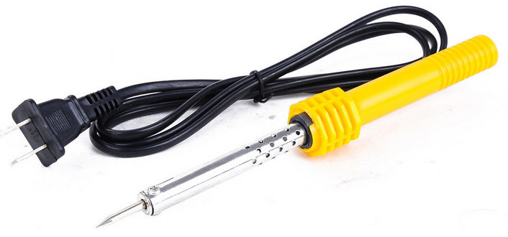

* 尖嘴钳
* **Needle-nose Pliers**

我们常用尖嘴钳剪掉一些多余的线或者引脚。我们这里可能用到不多。不过，尖嘴钳也是电子制作必备工具之一。

Needle-nose pliers are often used to cut off excess length from cables and wires. We won’t be using the pliers much for this project; however, they’re an essential tool in electronics projects.

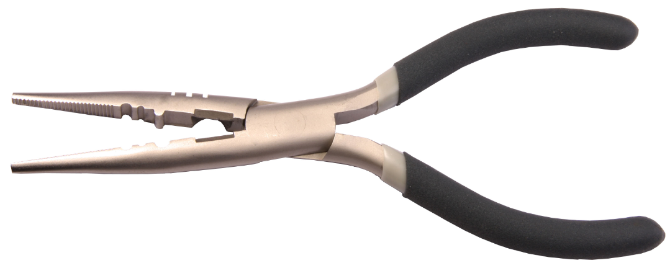

* 剥线钳
* **Wire Stripper**

所谓剥线钳，就是用来剥线的。如果没有的话，也没关系，可以用剪刀替代。只需要减掉外面一层皮，露出里面的导线，便于焊接。

A wire stripper is a hand-held tool used to strip the electrical insulation off of wires. The wire stripper can also be replaced with scissors if needed. When using this tool, only the first layer of insulation needs to be stripped, exposing the lead wire inside. This helps make the soldering process easier.



硬件材料

**Hardware Parts**

* 海盗船移动平台 × 1
* Car Base × 1

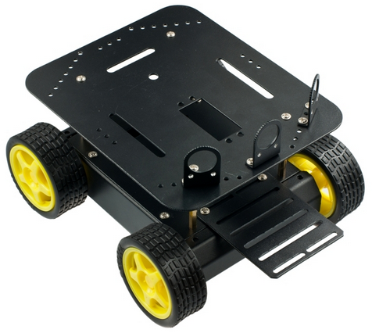

* Romeo BLE 控制器 × 1
* Romeo BLE controller × 1

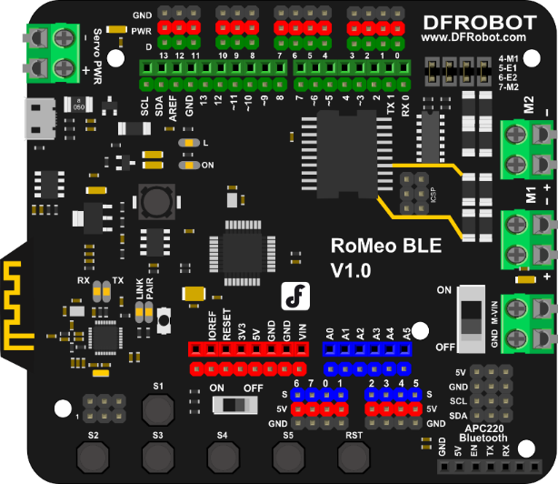

* Micro USB数据线 × 1
* Micro USB cable × 1

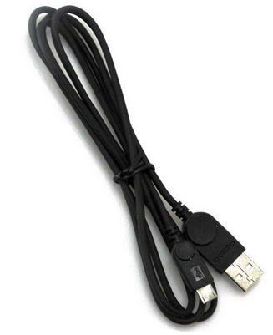

组装步骤

**Assembly Instructions**

工具准备就绪后，我们就要开始开工了！海盗船的底盘组装非常容易，只需要按照以下步骤一步步安装就行了。

After preparing the necessary tools and hardware pieces, it’s time to get started! Assembling the Pirate’s mobile platform is straightforward — just follow the below instructions step-by-step.

**STEP1**：安装电机

**STEP1: Assemble Your Own Motor**

拿出零件包，有找到8个长螺丝吗？那就是用来固定电机的。按下图位置摆放电机，找到对应的8个固定孔，拧上螺丝就行了。

Look in your parts bag for eight long screws. These are used to fix and secure the motors in place. Place the motors in the correct alignment, then screw them into place as shown in the picture below.

这里可能需要注意的一点是，零件包里面还有配有垫圈和锁紧垫片。垫圈可以用于增加摩擦力，使电机固定更牢固。锁紧片用来防止螺母由于震动可能导致的松脱。

Please note that washers and gaskets are also included in the parts bag. Washers can be used to increase friction, which helps fasten the motors into place. The gaskets help prevent the screw nuts from loosening and falling off due to the Pirate’s movements and collisions.

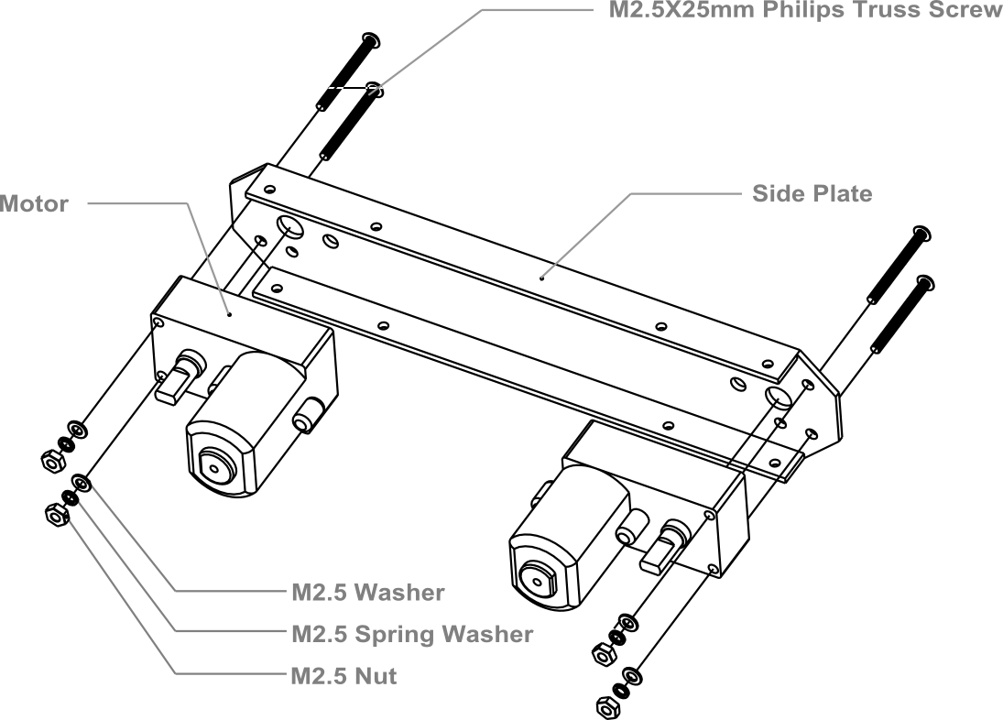

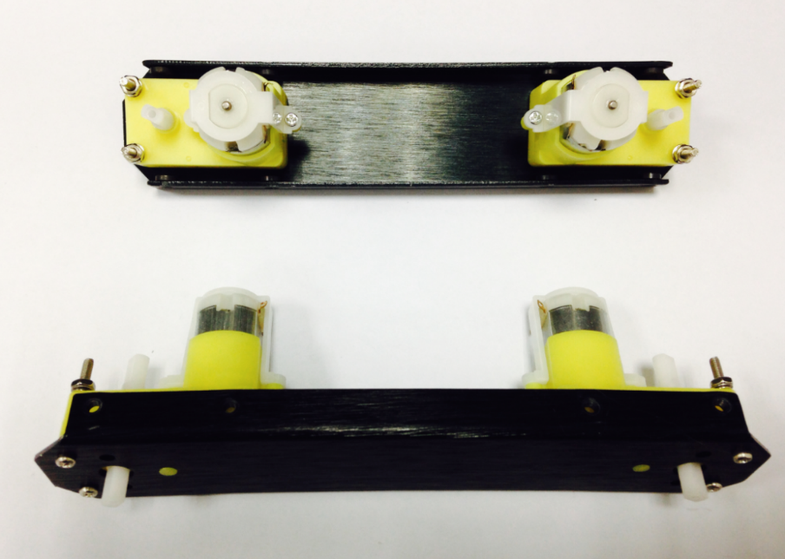

**STEP2**：焊接电机线

**STEP2: Soldering the Cables**

取出套件里自带的红黑导线，每个电机红、黑各一根，长度大约在15cm左右。用剥线钳在线两头剥去外皮，留下导线用于焊接在电机引脚上。将四个电机线全部焊好。

Take the black and red wires out of the parts bag. Attach one black and one red cable (15 cm long) to each motor (4 motors in total). Then use your wire stripper to strip the insulation at both ends of the wires (make sure not to strip too much—refer to the pictures below). Next, solder the wires onto the pins affixed to the motors. Repeat the soldering process for all four motors.

注意：焊接的时候，注意线序正确，可参照下图的红黑线的位置。

NOTE: Pay attention to the correct locations of the red and black wires when soldering. Please consult the following photos for details.

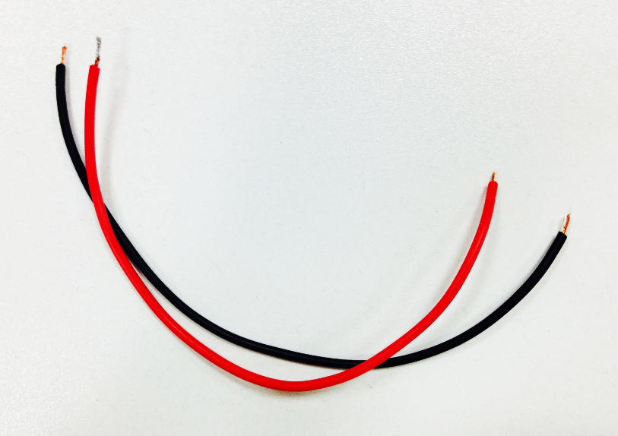 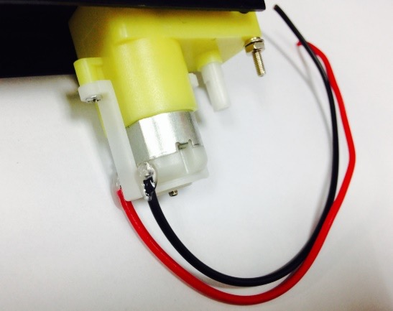

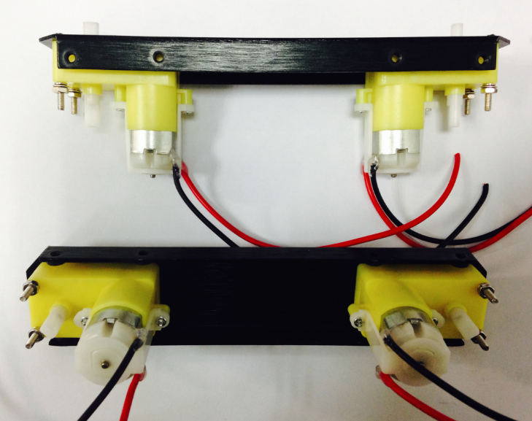

**STEP3**：安装**Romeo BLE** 控制器

**STEP3: Assemble the Romeo BLE controller**

找到零件包中的3个1cm长的铜柱，那是用于固定控制板的。首先，需要找到控制器的三个固定空位。并将铜柱拧上去。完成之后，再将控制器用螺丝固定上去。

Look in your parts bag for three copper supports. Those 1cm－long supports are used to fasten the Romeo controller board. As shown in the picture below, there are three holes in the controller board. Place the three copper supports into the holes, then fasten them into place with the appropriate screws.

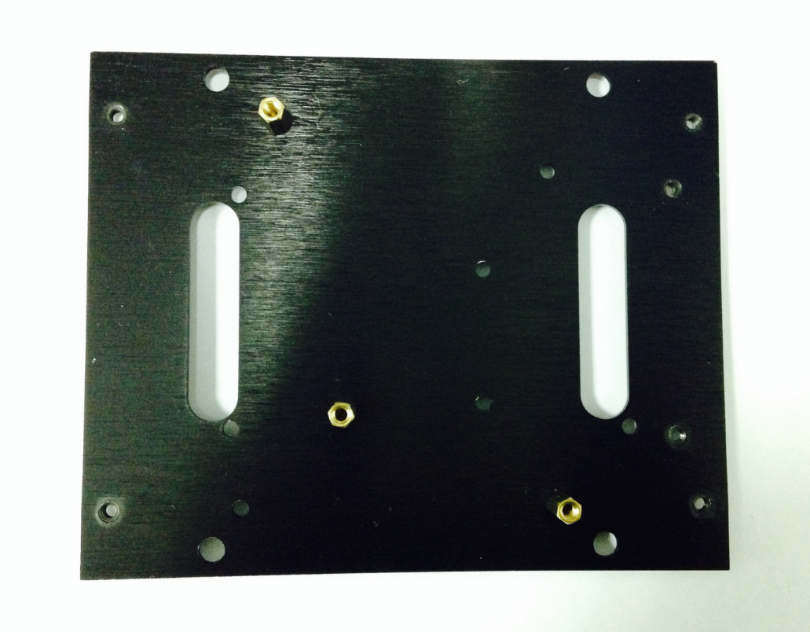

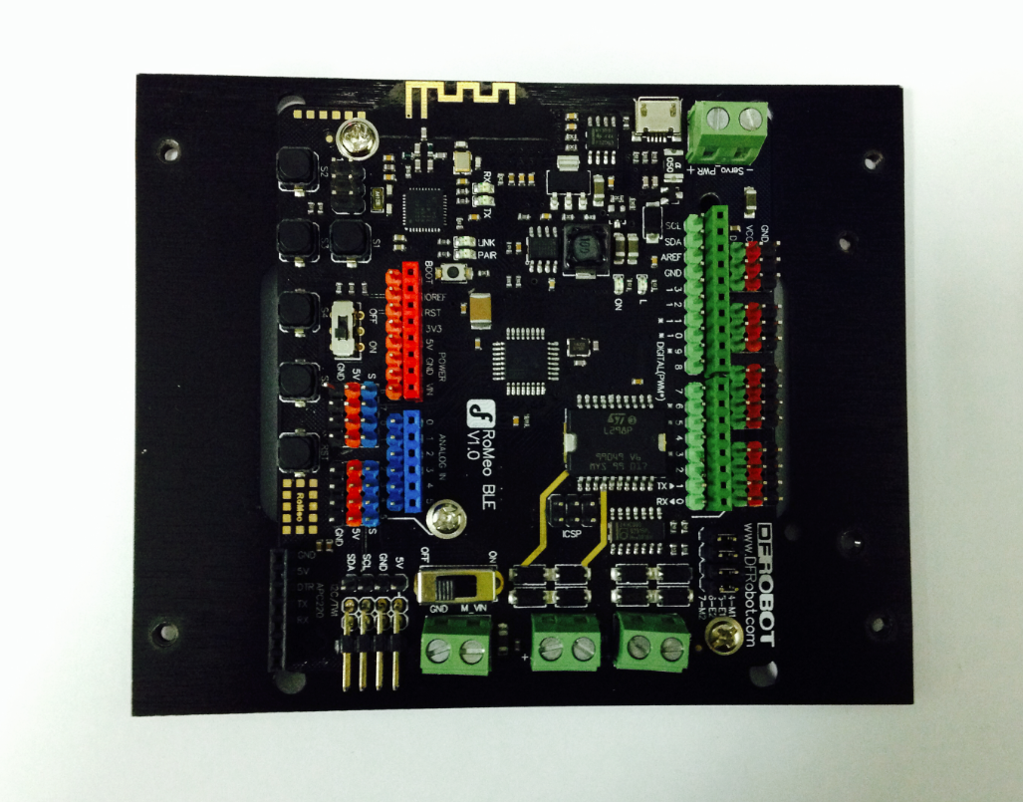

**STEP4**：安装电池盒

**STEP: Assemble the Battery Box**

取出独立包装的两个沉头(顶部是平的)螺丝，按下图装配图，将电池盒固定到底盘上。

Take out two countersunk screws (their heads are flat). Then follow the steps shown in the picture below and affix the battery to the car base.

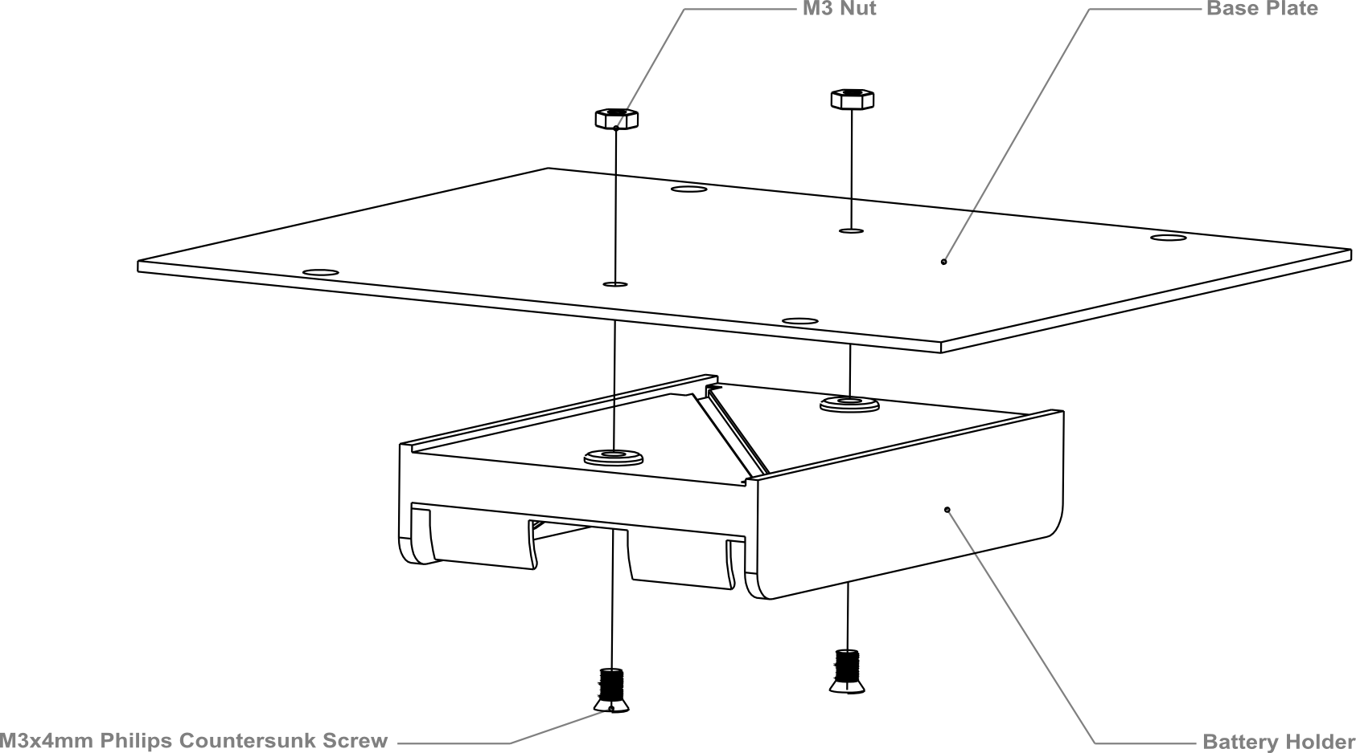

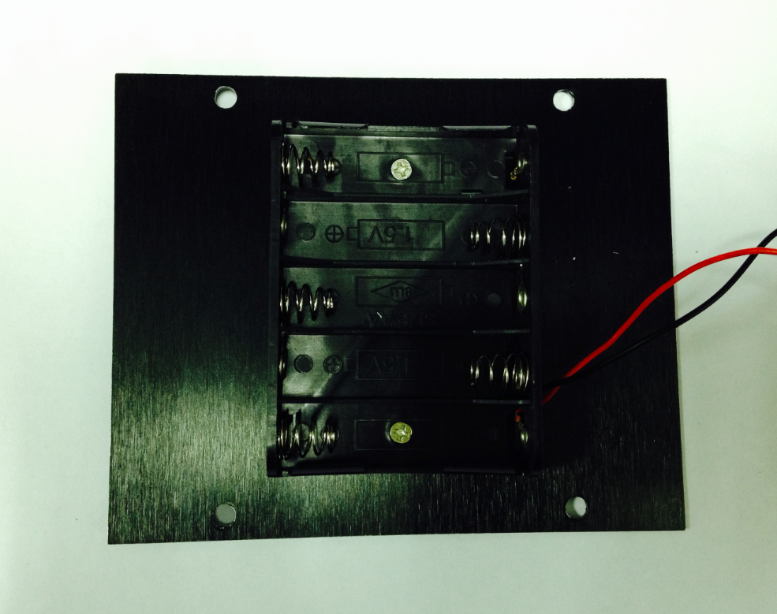

**STEP5**：制作电源开关

**STEP: Crafting the Power Switch**

我们都知道需要用电池来给机器人供电。平时不用的时候，需要断电来节约电量，那电源开关在这里就起到作用了。先按装配图将机器人的开关位置安装好。

Batteries are the essential lifeblood of robots. To control power usage, we need to use a power switch: the switch turns off power when not in use, thus preserving electricity and battery life. Refer to the picture below before assembling and installing the power switch.

安装的时候注意垫片和螺母的顺序。

Please pay attention to the sequence of the gaskets and screw nuts when assembling the switch.

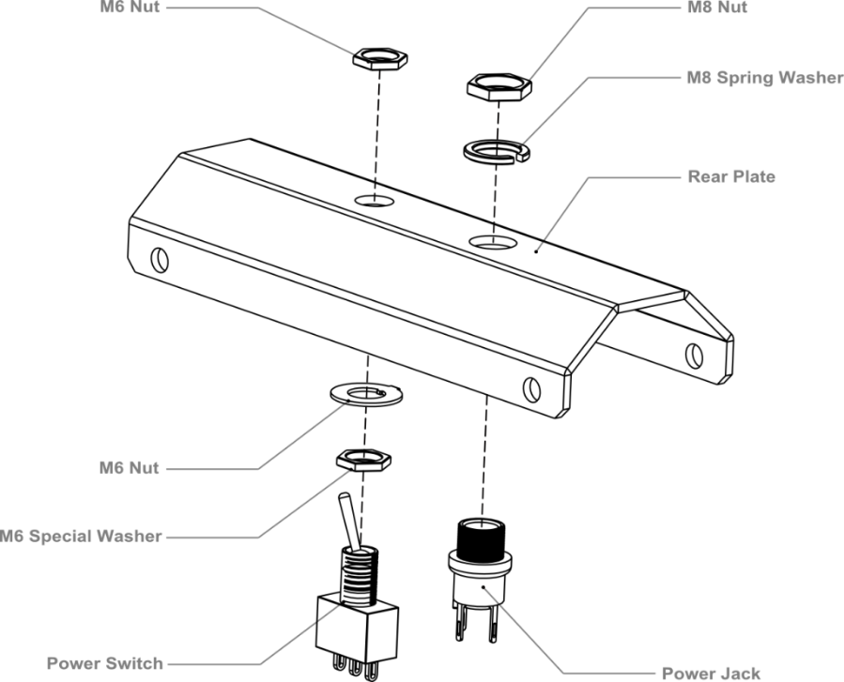

固定完成之后，就要开始焊线了，取出前面焊接电机连接线剩余的部分，可用于开关。同样，用剥线钳剥去线两头的外皮，留出导线部分用于焊接到开关的引脚上。焊接的时候注意看清楚开关的引脚位置。

After assembling the switch, we want to start soldering its wires. Take some of the remaining wire leftover from before. Strip the wiring off both ends of the cables so that the inside of the wire is exposed (same process as with the motors before). We want to solder the exposed end of the wires to the pins on the switch. When soldering, it’s very important that we note the position of the switch’s pins.

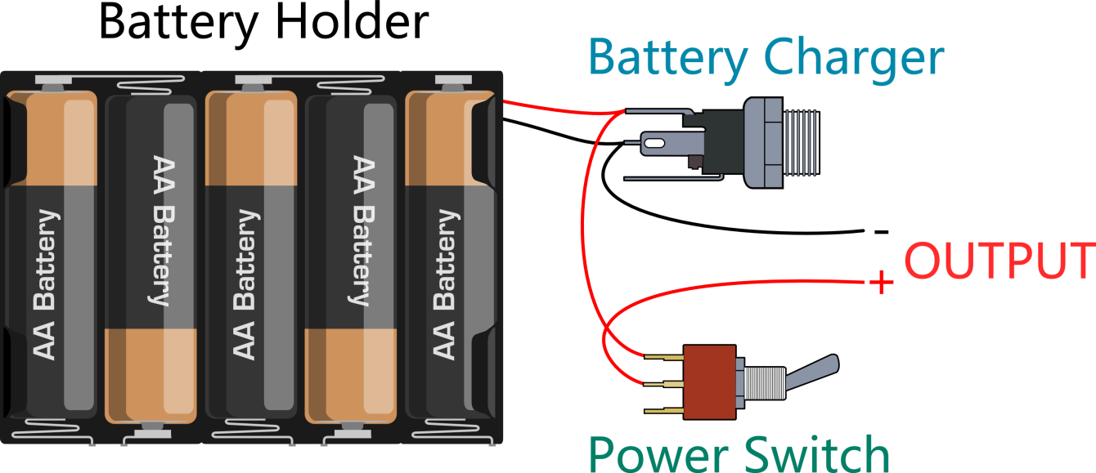

我们一步步来：

Let’s do this step by step.

1. 连接开关和充电接头。注意找准位置。

Connect the switch to the battery charger. Pay attention to the exact location of both items.

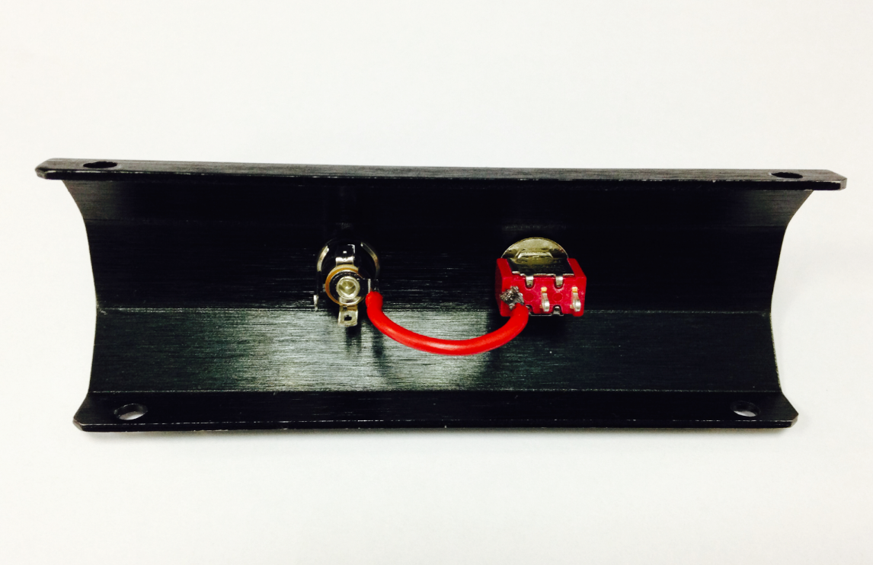

1. 按上图连线图，将电池盒的两根线焊接到充电接头上。

Solder the red cables connecting the switch with the battery charger as shown in the picture above.

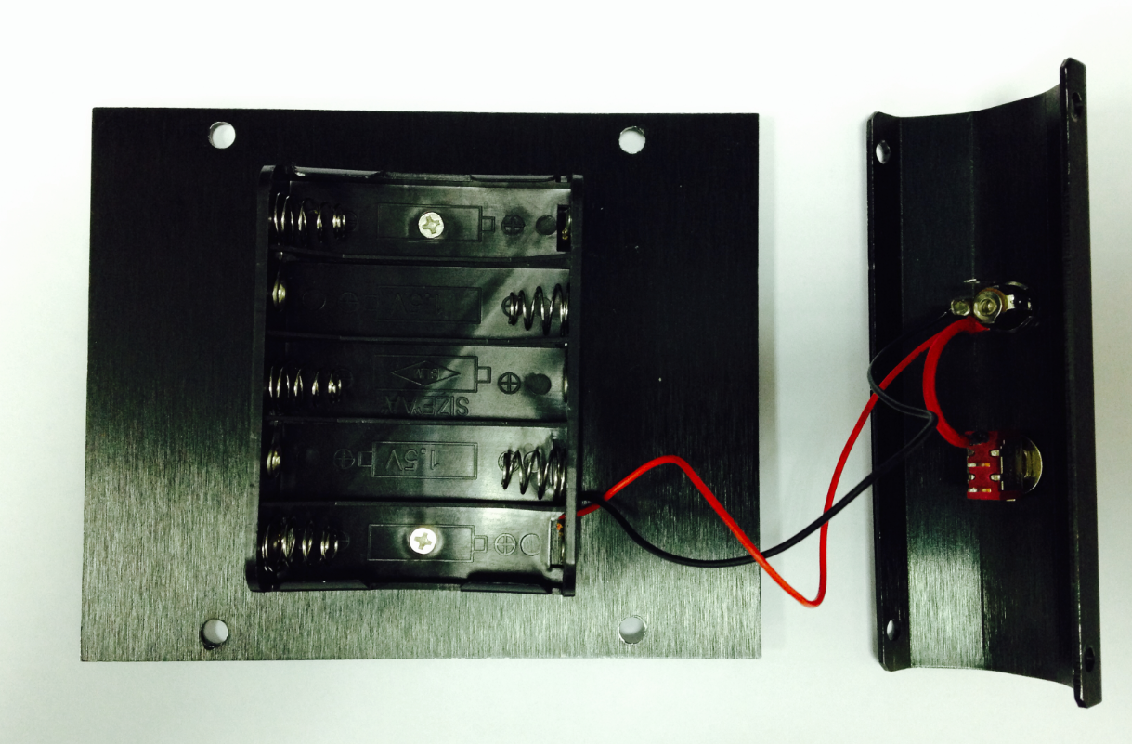

来张大图，看的清楚点！

Here’s another picture to make things clearer.

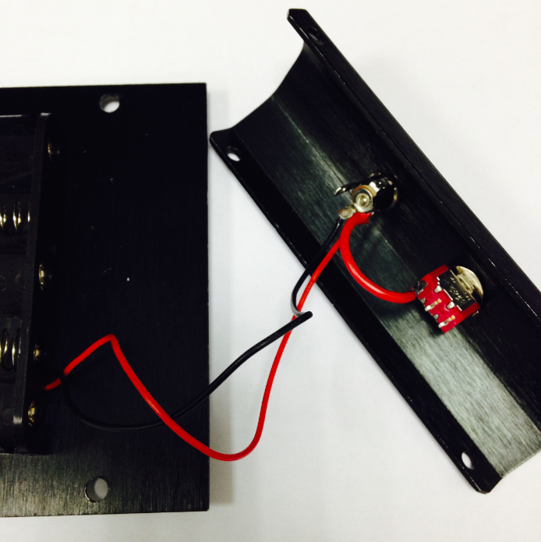

1. 最后，从充电接头和开关上引出正负极电源，用于接到后面的Romeo BLE主控器上。

Finally, take one red cable and one black cable. Attach one end of one cable to the negative pole of the battery charger and one end of the other cable to the positive pole of the battery charger. Then attach the other ends of both cables to the Romeo BLE controller.

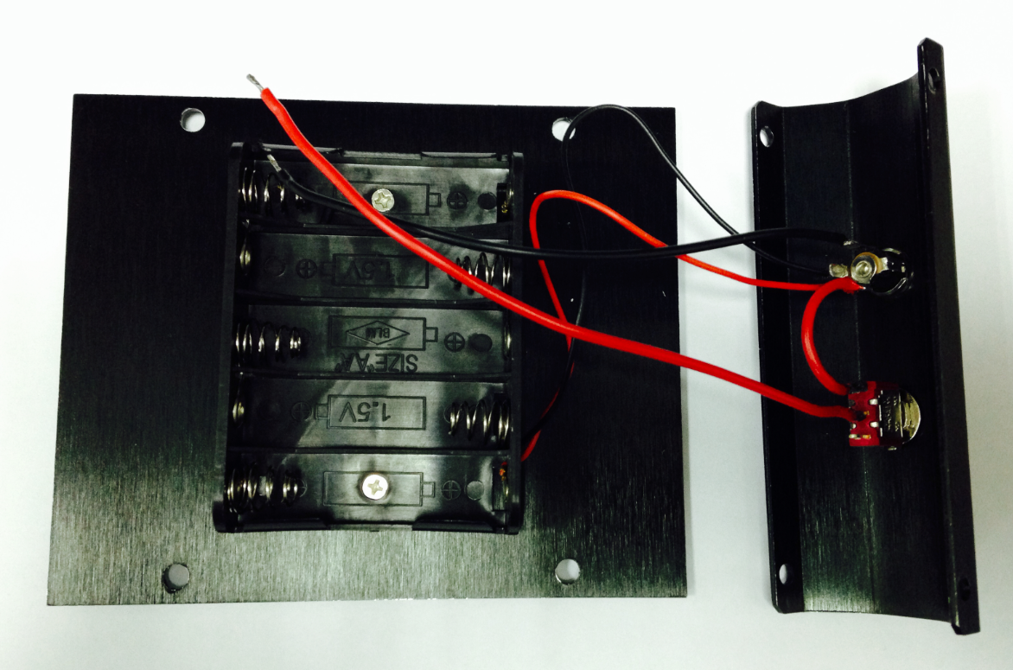

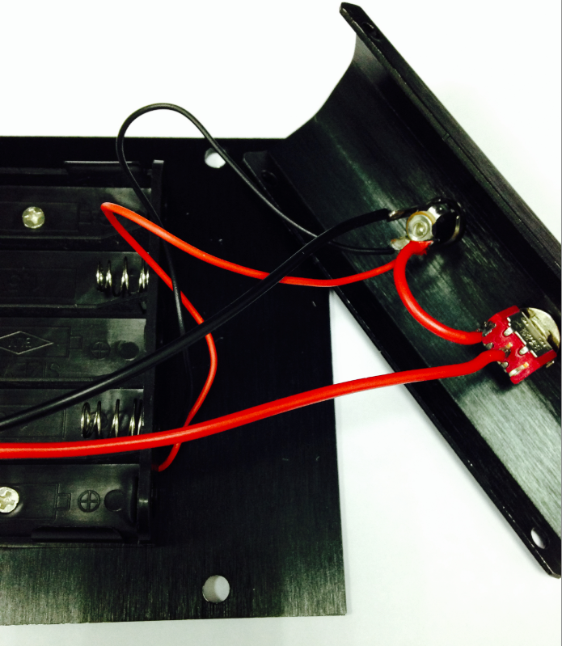

同样来张放大图，清楚是怎么连接的吗？最后，检查一下焊接的线是否和一开始的连线图是吻合的。

Looking at this enlarged picture should give you a better idea of how the wires should be connected. After soldering, make sure to check and see if your wiring between the battery and Romeo controller is consistent from start to finish and matches the above pictures.

**STEP 6**：组装底盘

**STEP 6: Assemble the Car Base**

用8个M3×6mm的螺丝将前后板固定到侧板上。按下图装配图安装。

Using eight M3x6mm screws, attach the side plates to the front and back bumper plates as shown by the diagram below.

注意：拧螺丝的时候，不要一开始就将螺丝全拧紧，导致下一步安装上层板的时候。螺丝孔对应不上。

NOTE: When tightening the screws during this step, make sure not to fully tighten the screws at first — this way, we can easily detach the top board in later steps should we need to make adjustments.

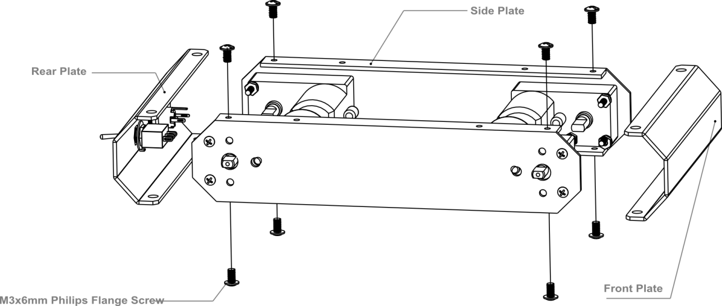

安装完后，将底板固定上去，见装配图。

Then, re-attach the base plate to the body of the car as shown in the picture below.

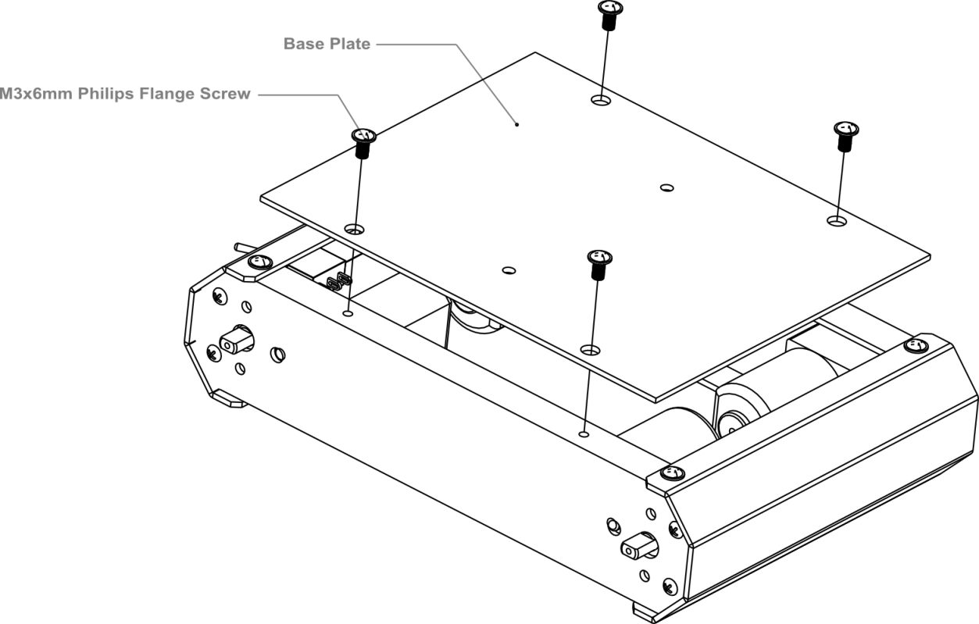

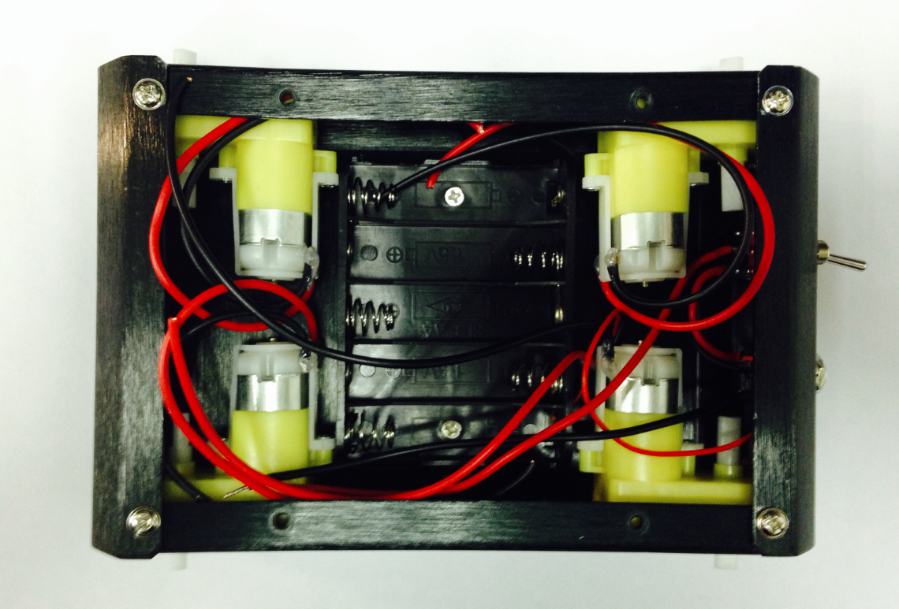

完成后的样子，记得装上电池！

** This is what the car base should like after it’s been assembled — remember to install the battery pack!.

**STEP 7**：连接电机

**STEP 7: Connect the Motors with the Microcontroller Board**

这一步我们需要将电机和我们的控制器连接起来，按下图连线图将电机线一一接到电机驱动的接线柱上，并用螺丝刀拧紧固定。

Now we need to the motors with the microcontroller board. Carefully follow the following diagram: the left motor’s red and black wires should be soldered into M2; the right motor’s red and black wires should be soldered to M1. Pay special attention to the battery pack: the black wire should be soldered into the wire port reading GND, while the red wire should be soldered in the wire port labeled VND. Use your screwdriver to loosen and tighten the wire ports — make sure these ports are fastened well once the wires have been inserted.

注意：同一侧的两个电机需要固定在同一个电机驱动接口上。

NOTE: Make sure the wires from one motor (i.e. the left motor) are soldered into the motor port. (i.e. the M2 port on the diagram below — do **not** solder one motor’s wires into two separate ports.)

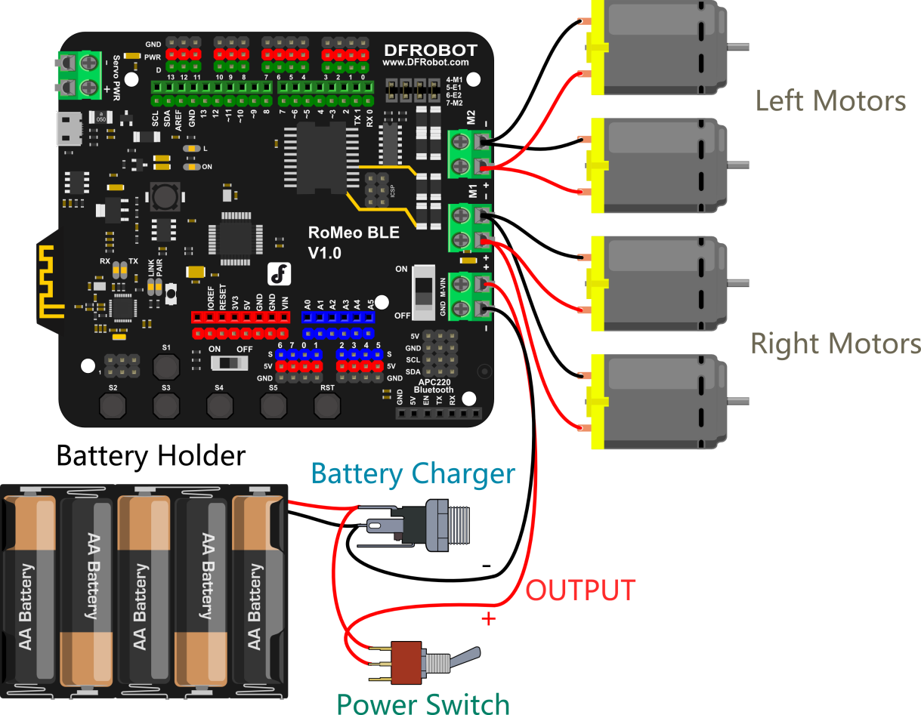

连接完成后，我们需要盖上顶板。盖顶板前，可以先装上传感器板。如果用不到的话，可以先不装。

After soldering the motor wires to the microcontroller board, we’re ready to attach the top plate to the base of the car.

Before we attach the top plate, you have the option of attaching a sensor plate (see diagram below) — if you don’t plan to use sensors just yet, you can skip this extra step.

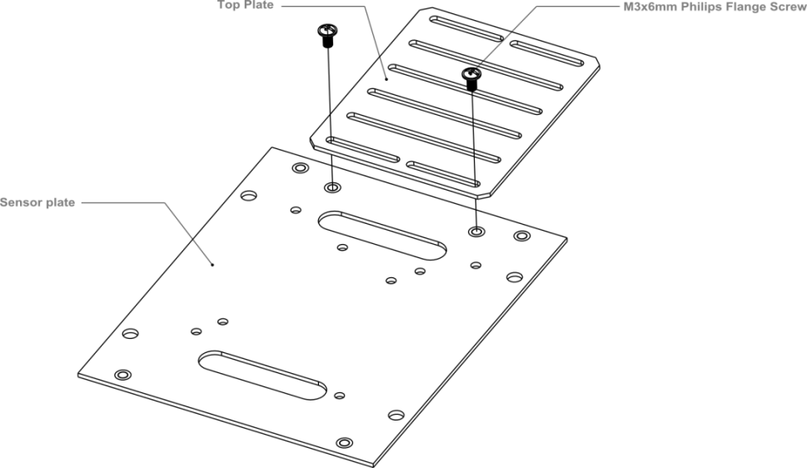

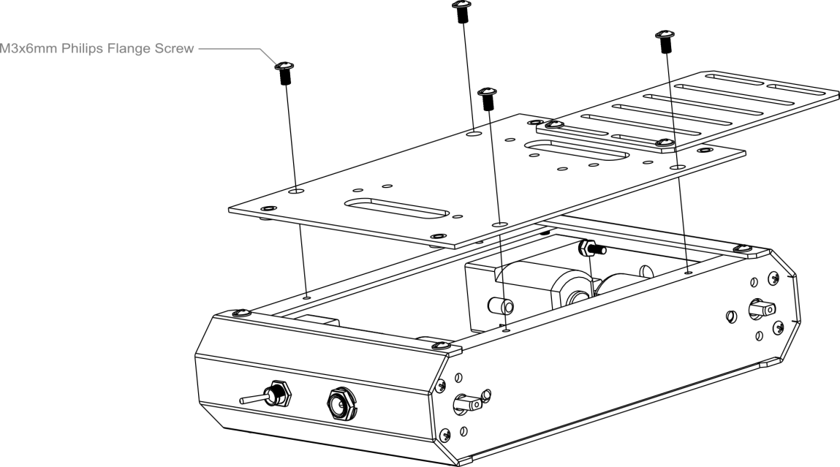

安装完成后，如下图所示。

After attaching the top plate, your Pirate should resemble the picture below.

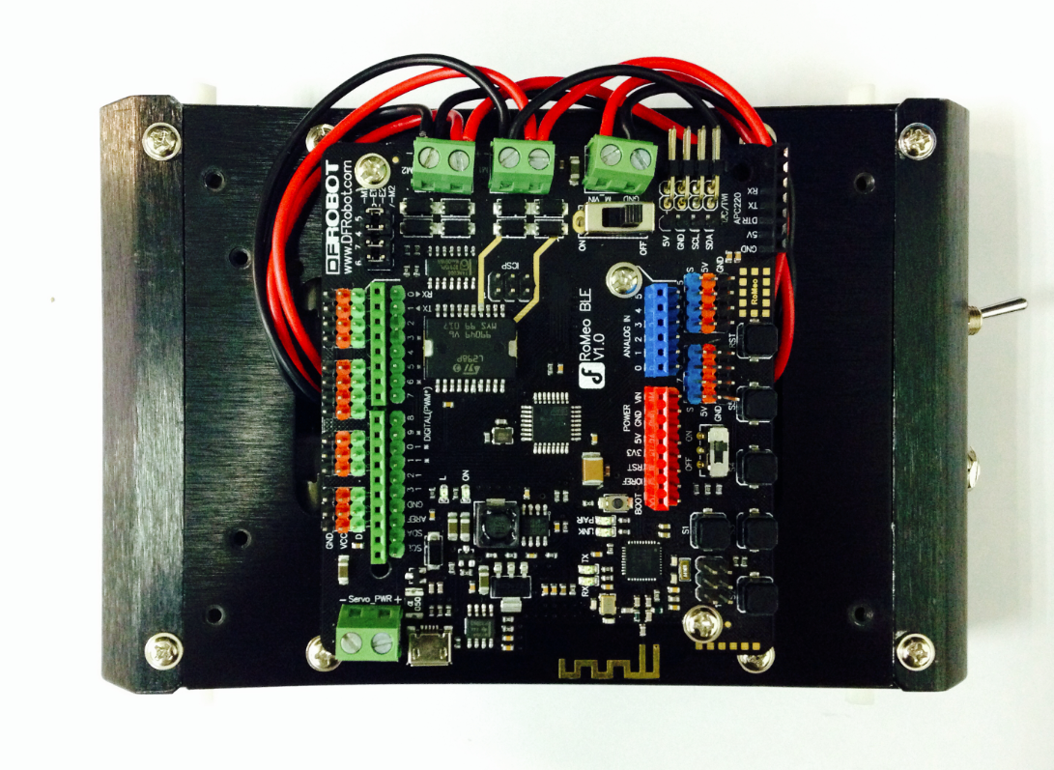

**STEP8**：安装上层板

**STEP8: Attach an extra level to the Pirate**

找到上层板的四个安装孔位，拧上螺丝。

Find the four holes on the base’s top plate. Screw in the four M3x60mm Copper Standoffs, then attach the additional top plate as shown in the diagram below — use M3x6mm screws to affix the plate to the copper standoffs.

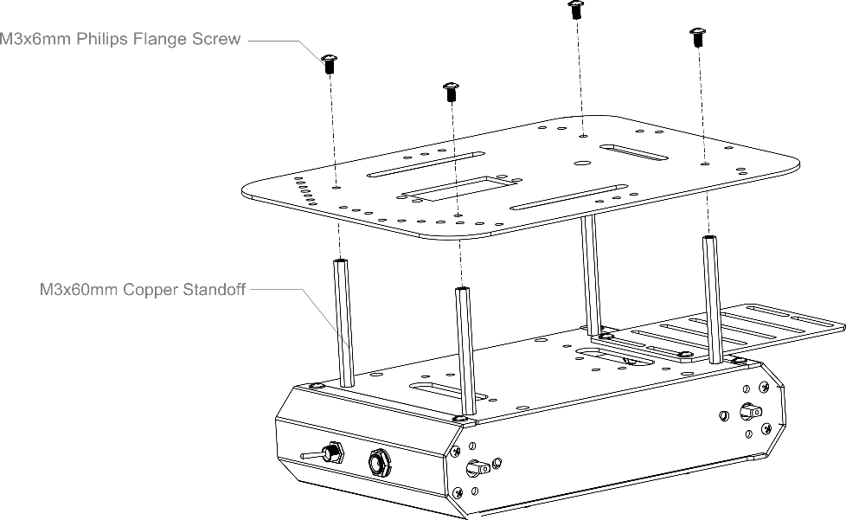

装上轮子，大功告成！

Toss some wheels on your Pirate and you’re ready to let it whip!

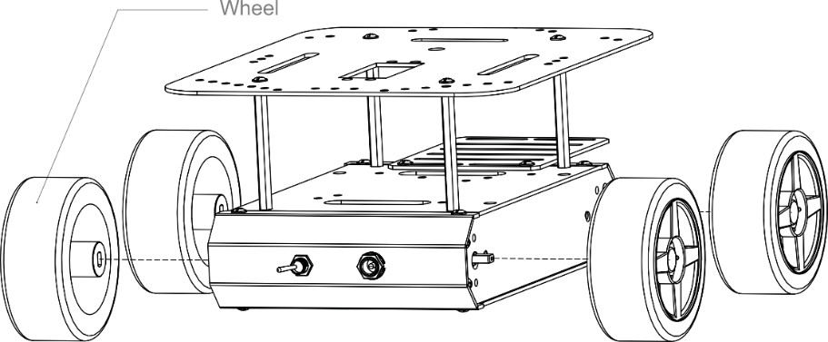

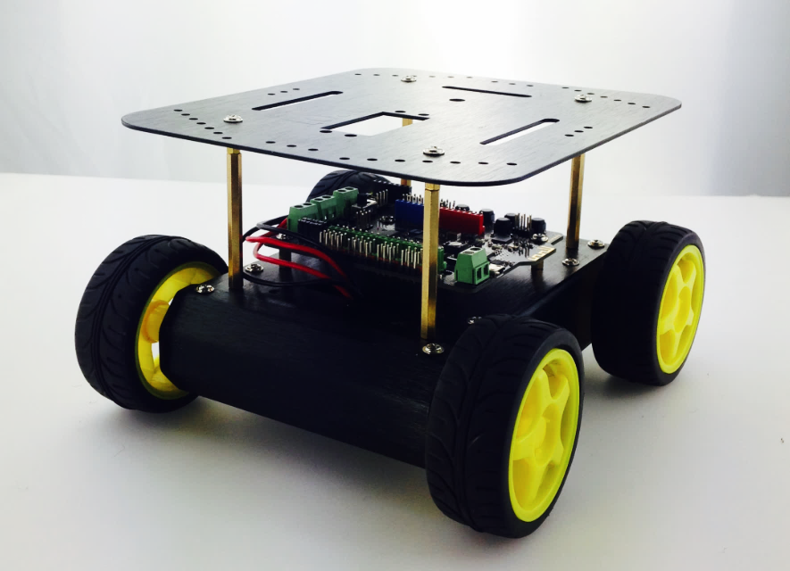

输入代码

**CODING**

组装完成后，机器人已经有了它的身体了。但还没有思想，所以，我们需要通过给她下载代码来赋予它“生命”，让它具有思想。可直接从样例代码包中找到MotorTest.ino代码。

After assembling, it’s time to upload some code onto the microcontroller and get the Pirate moving. The robot has all the components for moving once assembled. Look through the sample codes for the Arduino file titled “MotorTest.ino”.

样例代码MotorTest：

Sample code MotorTest：

#include <DFMobile.h>

DFMobile Robot (4,5,7,6); // initiate the Motor pin

void setup () {

Robot.Direction (LOW,HIGH); // initiate the positive direction

}

void loop () {

Robot.Speed (255,255); //Forward

delay (1000);

Robot.Speed (-255,-255); //Back

delay (2000);

}

下载完成后，电机是否有动静呢？如果没有动静的话，检查电池是否安装正确。如果电机转动了，那恭喜你，完成第一步的下载成功！

Download the code, then upload it to your microcontroller. The motors and wheels should come alive in a hurry. If not, check to see if your batteries and power switch are properly installed. Once the motors are working, congrats! You’ve completed a big step — it’s almost time to put our rubber to the road.

再仔细观察下，小车是不是按照我们特定的前进1s，后退1s呢？如果连这个都一样，那你太幸运了，你的电机连接方式和小编一模一样，你不需要做任何的调整了，只需轻松的将下面部分内容大致浏览下就行。不过，相信大部分人，还是需要做电机调试的。调试之前，我们首先需要先简单了解下机器人的移动方式。

Then observe your robot car and check if it may move forward within 1 second and move back within 1 second. If that’s the case, GOOD LUCK. You don’t have to adjust the components. For those who need to make some adjustments to the car base or motors, please find the following information about how the robot moves.

Check to see if your Pirate follows the code shown above: it should move forward for 1 second, then reverse for 1 second. If that’s the case, just skim the content below and then you’re ready to go!

Most people, however, will need to make adjustments to their motors. Before we do that, let’s briefly review how our Pirate’s motor function and code works.

如何让机器人前进？

**How do we make our robot move forward?**

多了不容易理解，我们就先拿前进来说吧，如何实现机器人的前进呢？通过下面这张图来说明小车机器人是如何前进的。

In order to understand this question, let’s first examine our robot’s forward movement.

The diagram below illustrates this forward movement.

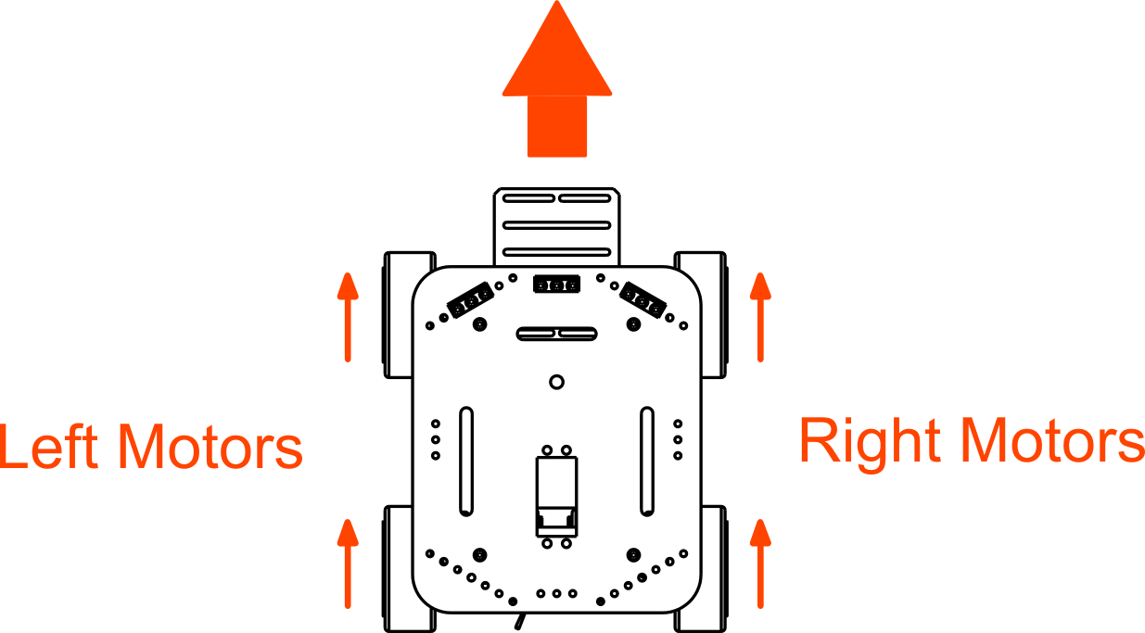

箭头所指是轮子的方向，从图中可看到，只有当左右轮子都往前转的时候，小车是能够做到前进的。

The red arrow above represents the direction of the wheels. As it is shown in the map above, the car can move forward only if both the left and right wheels/motors are moving forward. As shown above, the Pirate only moves forward when both the left and right motors and wheels are moving forward.

代码回顾

**Code Synopsis**

代码的第一行如下所示：

The first line of code is:

#include <DFMobile.h> // call library

这一行，你不需要过多理解。调用了一个名为”DFMobile”的library，常被称为“库”。我们在代码里使用了DFMobile的库中的函数，所以，需要在代码的一开始指出所用的库。

We don’t need to think too much about this line. All we’re doing is calling upon/employing a set of functions — the DFMobile library — that exist outside of Arduino’s basic framework. For more information on Arduino libraries, please check out the Arduino website.

接着往下，

The next line of code is:

DFMobile Robot (4,5,7,6); // initiate the Motor pin

这个函数就是调用的DFMobile库中的。放在代码的一开始，用来初始化电机引脚的。我们在后面的代码中都会用到。

This function is taken from the DFMobile library (that is, it’s not a universal Arduino function). We use it here to initialize the motor pins (4, 5, 7, 6) on the microcontroller — without this, the motors won’t start.

We’ll be using this function later on as well.

函数格式如下：

Take a look at the function below:

**DFMobile Robot**

**(EnLeftPin,LeftSpeedPin,EnRightPin,RightSpeedPin);**

这个函数是用来初始化电机引脚的，分别有四个参数：

This function is used to initialize the four motor pins (4, 5, 7, 6) and is divided into four separate parameters:

**EnLeftPin**： 左电机使能控制引脚

Pin that controls left motor direction

**LeftSpeedPin**：左电机速度控制引脚

Pin that controls left motor speed

**EnRightPin**： 右电机使能控制引脚

Pin that controls right motor direction

**RightSpeedPin**：右电机速度控制引脚

Pin that controls right motor speed

所以，之后的代码都需要在开始对电机的引脚进行设置，不可或缺的部分。注意，这个函数需要放在 void setup() 函数中初始化。

Please note: the Pirate’s motors won’t run without the inclusion of this function. Also, this function must be placed within the void setup() field in your Arduino sketch.

在 void setup()函数中，我们对小车的正方向做了设置，这里特意对正方向重点说明。通过前面的测试代码后，我们发现电机的转向并不与我们代码相符，那是由于电机的线序顺序导致的，电机没有正负，上电后就能运转，把正负极对换则是相反的顺序。

In testing the Pirate’s forward motion before, we might’ve encountered a certain problem: the car will start to drift, change directions and not quite follow the code we’ve given it. This is due to the motor wires not being soldered to the batteries in the correct manner.

所以，电机无非就两个顺序，正转和反转。我们在代码中通过LOW/HIGH来调整电机的正反转。我们这里并不制定LOW就是正转或者反转，因个人接线情况而定。

Don’t worry — we can correct this through code. By using LOW/HIGH values, we can adjust the direction of the car’s turns.

* 如何调整小车正方向？

**How to Adjust the Straight Direction for the Robot Car?**

调整电机的方向，我们需要用到下面这句语句是：

To adjust the direction of the motors and wheels, we need the following line of code:

Robot.Direction (LOW,HIGH);

函数格式如下：

The function is as follows:  
**Robot.Direction (LeftDirection, RightDirection);**

这个函数是用来设置电机的正方向的，函数分别有两个参数LeftDirection和RightDirection，可写入值为（LOW/HIGH）。

This function is used to make the motors move in a forward direction. The function is divided into two parameters: LeftDirection & RightDirection, which are written in the Arduino code as either LOW or HIGH.

我们在前面简单介绍了一下小车前进的实现方法。这里，就通过这个函数来是初始化小车的正方向。

Earlier, we briefly went over how to make the Pirate move in a forward direction. Here, we’ll use LOW/HIGH to correct the Pirate’s wayward movement.

举个例子，在这段样例代码中，LeftDirection设置为LOW。可能你的小车左轮并不是向前转动，而是向后转动。那么，你只需将LeftDirection 的LOW改为HIGH。重新烧录代码，此时，左轮应该是向前转动了。如果调试成功后，按同样方法调试右轮。

For instance, LeftDirection is set as LOW in the sample code. But left wheels of the robot car may rotate backwards instead of rotating forward. Now all you have to do is to change the LeftDirection from LOW to HIGH. The same methods would apply to the right wheels.

For example: in this sample code, LeftDirection is configured as LOW. Suppose your left wheels, rather than moving forward as they should, instead move backwards. In this case, change the configuration of LeftDirection from LOW to HIGH. Once you change it to HIGH, upload your code once more — you should notice that your left wheel is moving forward now instead of backwards. If this adjustment works, do the same for RightDirection (LOW to HIGH or vice versa).

一旦调试好小车的正方向，那么恭喜你！你已经基本可实现小车的基本功能了，在了解下样例代码最后一个函数Robot.Speed()。

Once you’ve successfully adjusted your Pirate’s direction, you’re set! Congratulations — you can now use all of the Pirate’s basic functions. Before finishing up, though, it’s worth it to briefly discuss the Robot.Speed() function.

函数格式如下：

Take a gander at the following function:

**Robot.Speed (LeftSpeed,RightSpeed);**

该函数是用来设置电机转动速度的。分别有两个参数，LeftSpeed和RightSpeed。可写入的值为-255~255。255最大值并且通过负号来表示方向。

This function with two elements (LeftSpeed and RightSpeed) is used to set the speed of the motor. You may write a number between -255 and 255. 255 is the maximum figure and the minus sign represents the direction.

This function is used to configure the speed of the motors. The function is divided into two parameters: LeftSpeed & RightSpeed. These parameters are written in Arduino code as a value ranging from -255 to 255. 255 is the fastest velocity moving forward; -255 is the fastest velocity moving backwards (that is, reversing).

因为在初始化函数中，我们已经调试过小车的正方向了，所以这里可通过Speed()函数控制速度的同时，还可控制方向。

We already configured the Pirate’s speed in the void setup() part of our code. Now, we can use the speed() function to control the car’s speed and even forward/backwards direction.

现在应该不难理解下面两句话了吧？

See if you can understand the following two lines:

Robot.Speed (255,255);

Robot.Speed (-255,-255);

上面一句表示全速前进，下面一句表示全速后退。代码就解释到这里，下面简单看下机器人的移动方式，也就是如何实现前进，后退，左转，右转等等。

The first line shows the car moving forward at full velocity — full speed ahead, if you will (aye aye, captain). The second line shows the car moving backwards (reversing) at full velocity.

In this sense, speed() is an indispensable function. Next, we’ll review our last section: the principles behind how the Pirate moves and turns.

机器人的移动方式

**How the Pirate moves and turns**

在下表中，罗列了几种常用的移动方式，同时也可以从表中看出其实现形式。举个例子，左轮方向速度为0，给右轮一个向前的速度，小车即可实现前左转。

The map below shows some regular way of movements for the robot car. For example, in case that speed of the Left Direction is zero, the robot would turn left if you offer the right wheels some force to move forward.

The following diagram displays a number of ways in which the Pirate can move and turn. For instance, if the speed of the left wheels is set to 0, that will cause the right wheels to move forward — thus, the Pirate would turn towards the left.

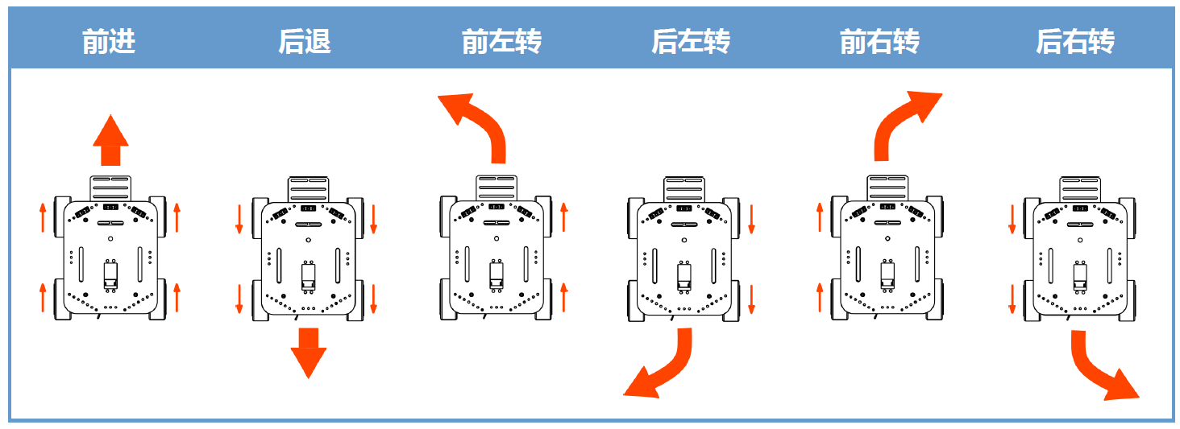

可以思考下，如果想实现小车原地转圈该如何控制？

Something to consider: how can we make the Pirate rotate in circles while stationary?

最后，还有一段测试代码可供测试,，可从代码包中找到MotorTest2.ino。这段代码不仅可测前进后退，还包含左转，右转。至此，你已经实现机器人的基础功能啦！

Lastly: if you want, you can run some more code to test and calibrate your Pirate’s movement. Open the “MotorTest2.ino” file. This code should help you better understand and gauge the capabilities of forwards and backwards movement, in addition to left and right turns. With this in mind, put those tires to the road (or carpet) and let’er rip!